Duong Le

IT360

Nav Dynamics Exam

1. Add a new employee and set SSN hidden and add a new ribbon “Medical” with a “Relatives” Group.

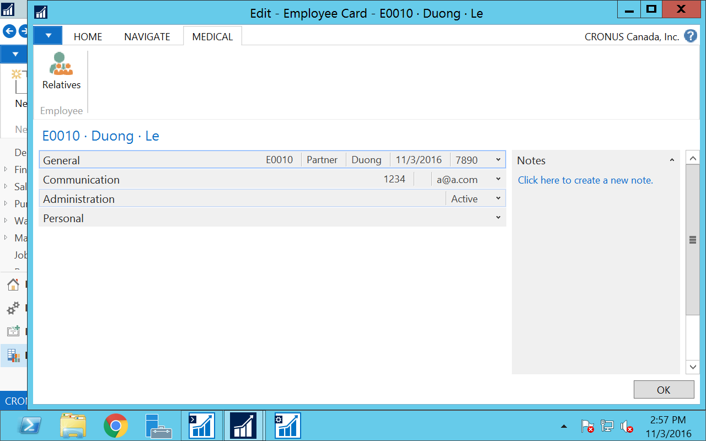

1. Salse and Purchase

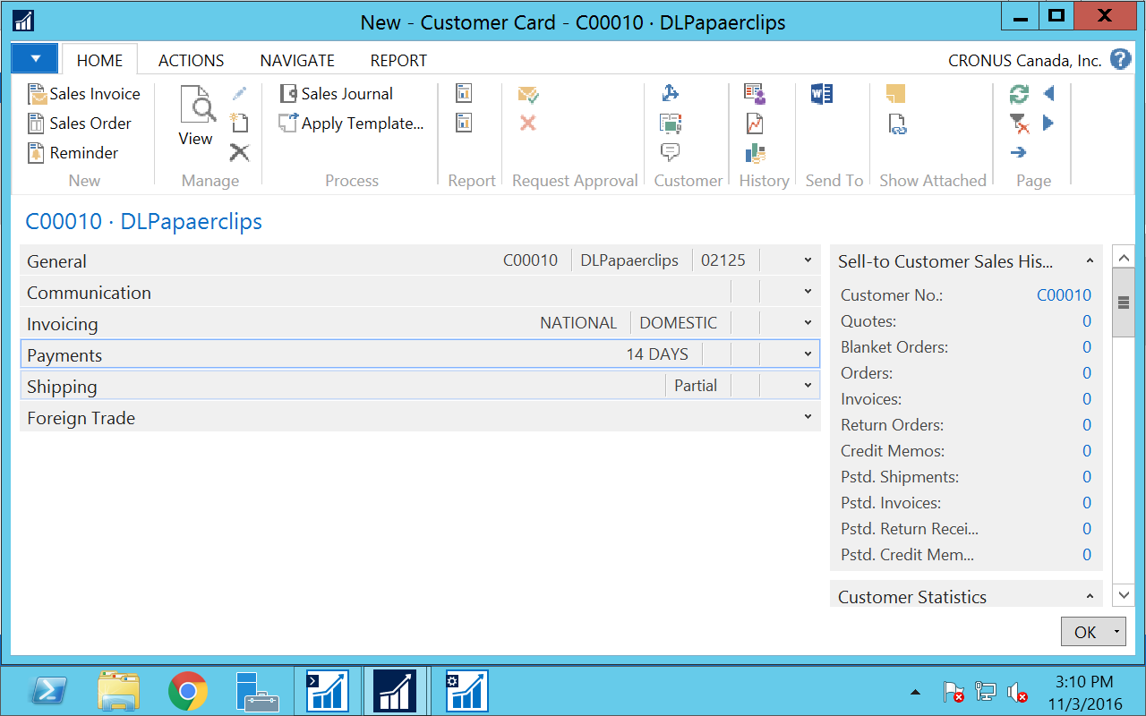

New Customer

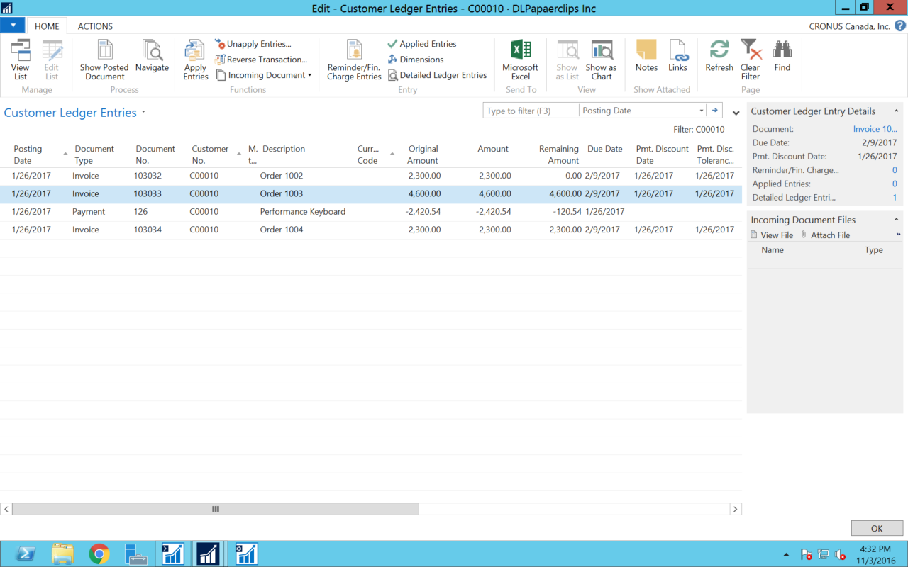

Customer Ledger entries

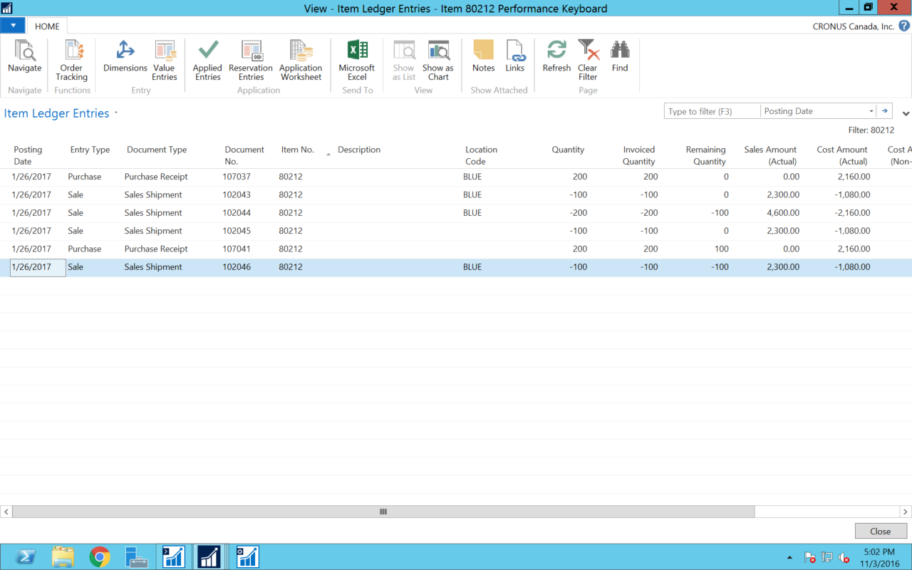

Item ledger entries

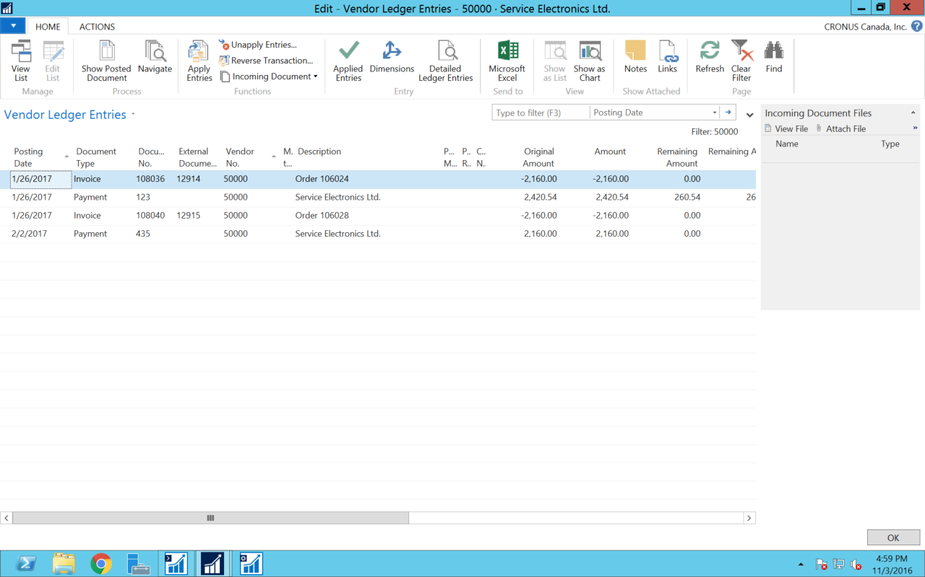

Vendors ledger entries